Superior Court of California,

County of Mono

***INVITES APPLICATIONS FOR THE POSITION OF***

Court Reporter

(Contracted Position)

Application Deadline: **Open Until Filled**

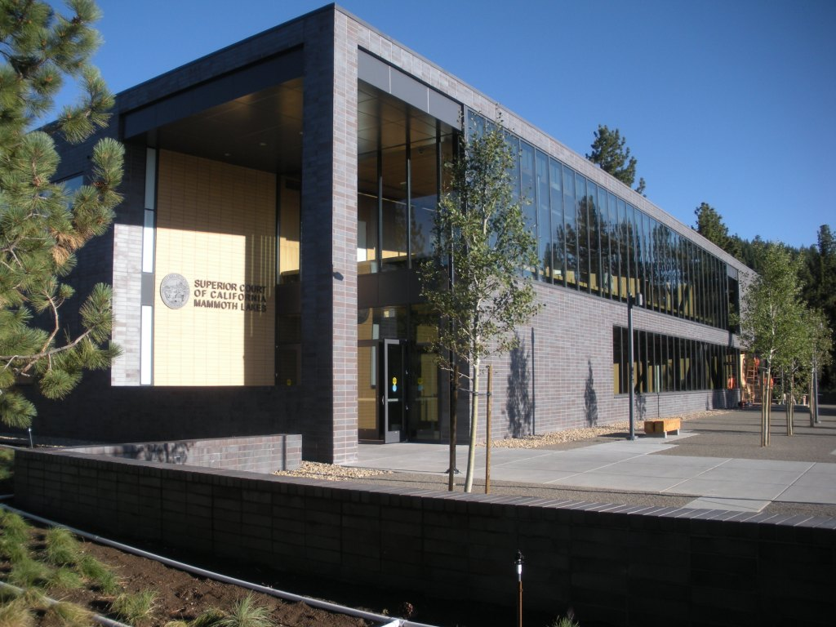

**New Mammoth Lakes Courthouse – the Main Courthouse for the Superior Court of California, County of Mono**

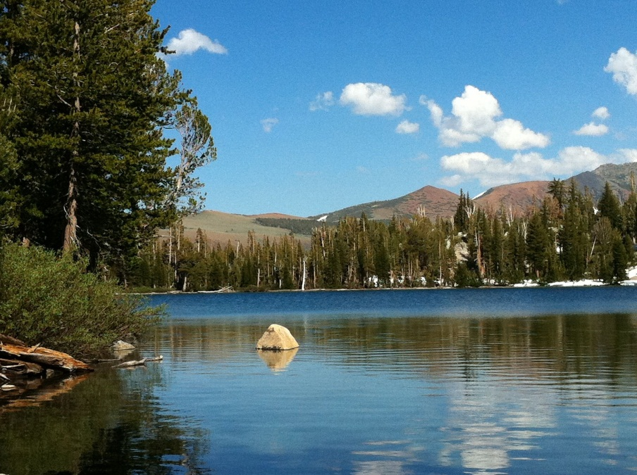

**Live, Work and Play in one of the Most Beautiful Places in California - The Eastern Sierras**

This contracted Court Reporter position is based at the main courthouse for the Superior Court for Mono County located in Mammoth Lakes. The town of Mammoth Lakes is a well-known destination recreation area, but it has much more to offer. Mammoth Lakes provides an entertainment, shopping and cultural center for Mono County. There are numerous restaurants, live theater, community college, shopping centers, movie theater and concert venues.

Mono County is a year-round resort destination with Mammoth Mountain Ski Area, Yosemite National Park, Mono Lake and other places of natural beauty nearby. The eastern gateway to Yosemite National Park is less than a 45-minute drive from the main courthouse in Mammoth Lakes. Working for the Mono County Superior Court provides an opportunity for professional development as well as enjoying the many recreational activities that California is known for: skiing and snowboarding, snowmobiling, hiking, fishing, cycling, golfing, camping, and more.

What first-time IT managers really need to know.

We asked 5 accomplished managers the things they would’ve done differently at the onset of their careers

**Contracted Court Reporter**

This is a contracted part-time position in the Mammoth Lakes courthouse with a negotiable salary. The successful independent contractor will provide court reporting services for a variety of case types including civil, family law, probate, and child support. Other assignments if accepted will be compensated outside of this primary assignment.

**Duties**

Independently contracted Court Reporters or Voice Writers report and transcribe the verbatim record of official court proceedings, prepare and certify transcripts, and, at the direction of the Court, reads the record aloud in court in accordance with applicable Government Codes, Rules of Court, and Statutes. Contractors provide their own reporting or voice writing and transcription equipment, software, and other materials per Government Code Section 70313.  Government Code Section 69950 authorizes Official Court Reporters and Voice Writers to charge, as independent contractors, a standard fee for transcription.

**Qualifications**

Possession of a valid Certified Shorthand Reporter (CSR) or Voice Writer certification issued by the Court Reporters Board of California.

**How to Apply**

**Send letter of introduction and Curriculum Vitae to: hr@mono.courts.ca.gov;**

**Mail to: Mono County Superior Court Deliver to: Superior Court, Mammoth Lakes Branch Attention - Human Resources Attention - Human Resources**

**P.O. Box 1037 100 Thompsons Way**

**Mammoth Lakes, CA 93546 Mammoth Lakes, CA 93546**

**The Superior Court of California, Mono County, is an equal opportunity employer.**